

Small Paws Design & Testing Report

Team Members:

Abhinay Khalatkar

Virendra Kadam

Prerna Tati

Neelima Sahu

# Prof. Dr. Swati Chandana

# Advanced Computer Science

SRH Hochschule Heidelberg

Summer 2022

## Introduction

When people abandon their pets, they are often left alone and helpless. They are at risk of developing diseases and dying from a variety of hazards. They usually wind up in animal shelters and are euthanized if they do not receive sufficient care. This software was created to assist and care for such animals, as well as enhance the adoption rate. This increases the animals' chances of survival and provides them with a loving family. We are also assisting in the reduction of animal overpopulation using this application.

## Approach and Description

**First Sketch Version:**

We first came up with first sketch of the application which is as follows:

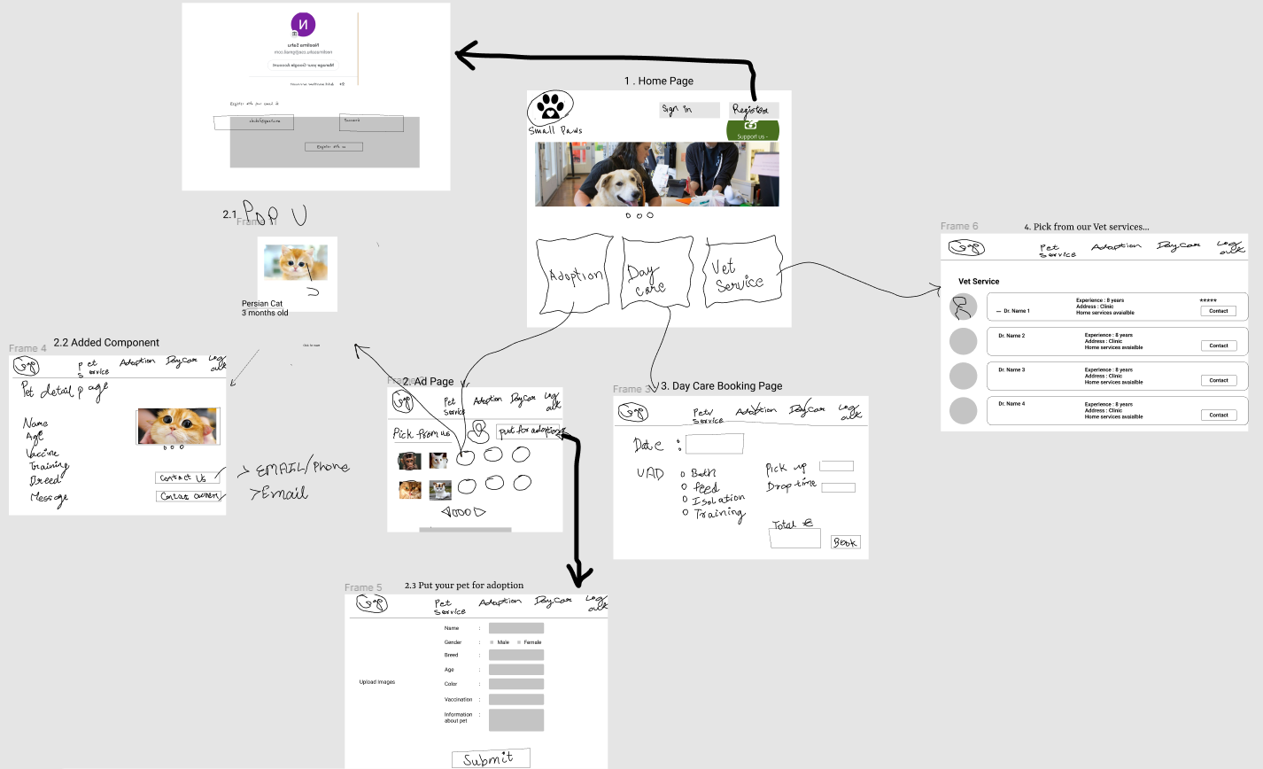

Figma Link of Version 1: <https://www.figma.com/file/HNIGehMxnaQxoKD5z1qkxj/Sketch?node-id=0%3A1>

**Second Sketch Version:**

**Page 1**

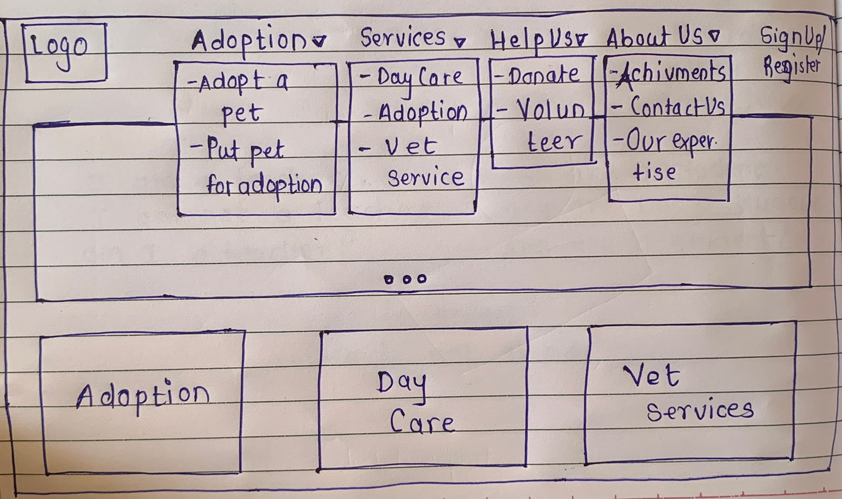

Page 2

Page 3

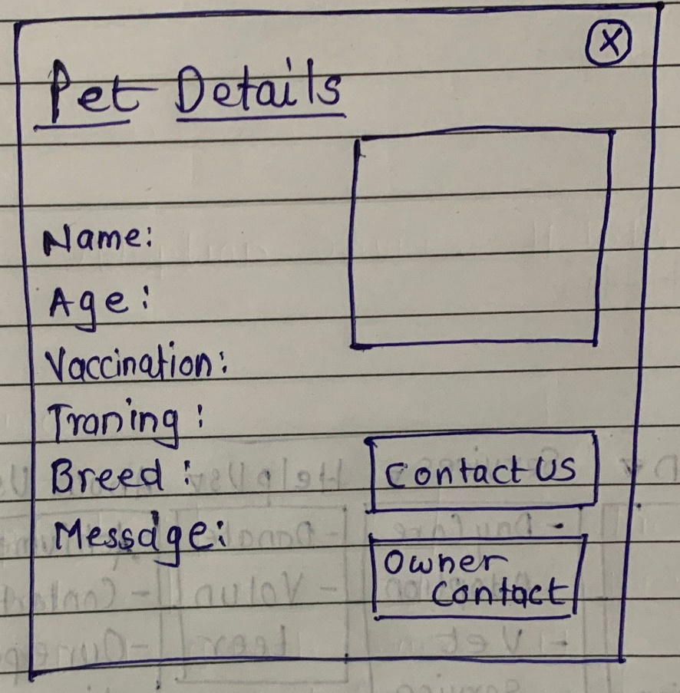

Page 4

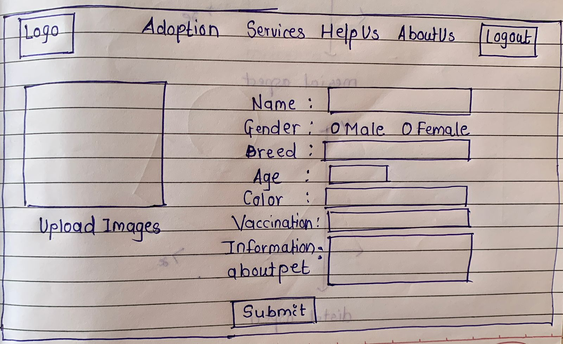

Page 5

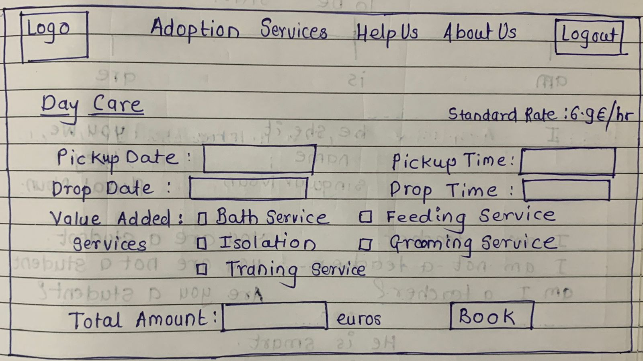

Page 6

## Page 7

## 

## Page 8

## 

## Page 9

## 

## **Page Navigation-**

## 

## Tests Performed:

1. Preference Testing:

On the first analysis with the team “Cloud 9”, and Shivani as the evaluator we got a SUS score of 52.8

Upon improving much on the first version we came up with the second and final sketch with a score of 82.2.

1. 5 second Testing:

Home Page:

On the first analysis with the team “Cloud 9”, could easily remember the services we offer from the Home Page and the message it conveys.

The services that they could remember are : Day Care, Pet Adoption and Vet Services.

## Conclusion

Since we worked upon the sketches by taking suggestions from Cloud 9 , our SUS score got better and the overall design pattern will make more sense to the user.